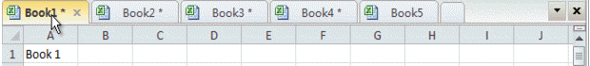

Amazing! Using Tabs In Excel Like Firefox, Chrome, Internet Explore 10!

The following short VBA code can help you to deal with the problem that convert text to formula as these steps:
1. Hold down the ALT + F11 keys, and it opens the Microsoft Visual Basic for Applications window.
2. Click Insert > Module, and paste the following code in the Module Window.
VBA code: Convert text strings to formulas
1  2  3  4 | Function Eval(Ref As String)  Application.Volatile  Eval = Evaluate(Ref)  End Function

